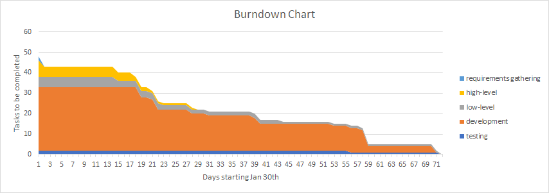

Requirements Backlog Tasks (Hours) Type of Job Done

**TYPE: Requirements Gathering, High-level Design, Low-level Design, Development, or Testing**

|  |  |
| --- | --- |
| Testing spreadsheet | testing |
| Sprint Docs (3) | reporting |
| Burndown Charts | reporting |
| AWS server set up (15) | Low level design |
| Admins creating new admins (3) | development |
| Customer info page (2) | development |
| Unit tests (2) | testing |
| Update Requirements Def (1) | Requirements gathering |
| Projects page (6) | development |
| Contact us page with google maps (5) | development |
| Tool-Shed logo (1) | development |
| Alert that reservations have been made | development |
| Slideshow carousel on main page (4) | development |
| UML Diagrams (3) | Low level design |
| Authentication (4) | development |
| Drawn Prototype (2) | High level design |
| External - nav bar (2) | development |
| Internal - navigation bar (2) | development |
| External - landing page(1) | development |
| Internal - landing page(1) | development |
| Internal - List of reservations by day (2) | development |

Requirements Backlog Tasks (Hours) Type of Job Done

|  |  |
| --- | --- |
| Internal - fee tracking (5) | development |
| Internal - reports (6) | development |
| External - delete future reservations(.5) | development |
| External - update future reservations(.5) | development |
| External - create new reservations with tools (4) | development |
| Internal - mark reservation as returned (1) | development |
| Internal - mark reservation as picked up (1) | development |
| Internal - delete reservation (.5) | development |
| Internal - update existing reservation (.5) | development |
| Internal - create new reservation (1) | development |
| Risk analysis in project plan | High level design |
| Internal - edit customer accounts (1) | development |
| Internal - create new customer account (1.5) | development |
| External - Allow customers to reserve tools (4) | developmentdevelopment |
| External - Customer account (1) | developmentdevelopment |
| Internal - View for all tools (3) | developmentdevelopment |
| Internal - Delete tool from inventory (.5) | development |
| Internal - Update existing tool information (.5) | development |
| Internal - Create new tool inventory (.5) | development |
| Programming language used (1) | High level design |
| Use Case videos (4) | Low level design |

Requirements Backlog Tasks (Hours) Type of Job Done

|  |  |
| --- | --- |
| Use Cases (4) | High level design |
| Framework to use (10) | High level design |
| Packages to use (bootstrap) (3) | Low level design |
| Database system (1) | Low level design |
| Communications set up for team (2) | High level design |
| Version control system set up (15) | High level design |
| Meeting with client on system goals (3) | Requirements gathering |
| Deciding models to use for DB (1) | High level design |
|  |  |
|  |  |
|  |  |
|  |  |
|  |  |
|  |  |
|  |  |
|  |  |
|  |  |
|  |  |
|  |  |
|  |  |
|  |  |